Share:
- Finding
→ P1: Add to shortcut toolbar w/ Undo, Redo and Find
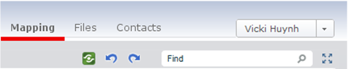
Note: This icon should be 16x16 px. The paper airplane above is a placeholder.
or
Note: This button uses the primary button style from dialogs
→ P1: Add sharing to context menu in Mapping client
Talked to Philip about this. It does not make sense to add Share to the context menu in the mapping client because context menus are for mapping objects (i.e. a topic, boundary, relationship, etc.). Because we only share the whole map, adding Share to the context menu breaks the context menu interaction pattern.
→P1: Go with latest design for organizing Versioning & Share panels.
(This replaces the Editing, Sharing and Versions panels in current implementation.
Send Email can be removed.)
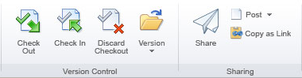
→ In context menu in Files client,
- P1 remove submenu from Share command
→ P1: Use better language for Descriptions add “your account” back in
Note: Visual design has not been applied to wireframe below.
Unless noted, the mock-ups in this document include the final visual design.
- P1: Map Share Limit Reached
Combine three below into one solution/ticket.
→ Make message more visually prominent
Our Visual Designer is out until Wed., Aug. 10th. We hope to have a design by Fri., Aug. 12th
→ Communicate options more clearly
need to work with PM to determine text changes.
→Decrease distance from message and actionable UI element
make part of warning message a clickable link as well as have a button at the bottom of the dialogue to change editable maps. This design will come once text for warning message is finalized.

- P1: Confirm dialogue suggests lots to do here
→ Only show confirmations message. Do not show other elements
Note: Visual design has not been applied to wireframe below.
Unless noted, the mock-ups in this document include the final visual design.
Managing User Privileges:
- Changing Access: Where to go to make changes
  - How to make changes
    - via “Share Again”
    - Sharing Details Pane
      - → P1: If nothing is shared, show “Not shared”
and remove Member and Guest sections
→ P1: Add share button to this state of File Sharing Details
    - Account Management is for people in/out. If in, Mem./Guest

→P1: less stuff in File Details
Remove the following fields from File Details. (Too much information interfered with the visibility of the File Sharing Details below in the 7/18 usability study.):  - Type  - Size  - Status | File Details should only contain:  - Name  - Created on  - Created by

→ P1: make File Sharing Details more prominent
File is not shared: | File is shared:  Note: Arrow icons are placeholders.

→ P1: Folder Details
Folder is not shared: | Folder is shared:  Note: Arrow icons are placeholders.

Design Deviations:
- P1: Account Details: content TBD
- P1: Center Pane
→Status column should show the same as the one displayed in File Details
→Apply visual design (as well as correct column, order of columns, etc.)

